Virtual Data Science with Python Apprentice Intern
Week 3 Report
Statistical Analysis and Hypothesis Testing
Dataset: Titanic passenger data (Kaggle)
Tools: Python, SciPy, Pandas, Seaborn
Prepared by: Vandana

1. Introduction
Weeks 1 and 2 explored the Titanic dataset visually and found several apparent patterns: survival looked strongly linked to sex and class, and possibly to fare and age. A visual difference between two groups is not proof of a real effect, though; it could arise by chance in a sample of 891 passengers. This week applies formal hypothesis testing to check which of these patterns hold up to statistical scrutiny, using p-values and effect sizes rather than eyeballed charts.
Four hypotheses are tested, each chosen because it was suggested by the exploratory work in Weeks 1 and 2:
- H1: Survival is related to sex (chi-square test of independence).
- H2: Survival is related to ticket class (chi-square test of independence).
- H3: Survivors and non-survivors paid different average fares (Welch’s t-test).
- H4: Survivors and non-survivors were different ages on average (Welch’s t-test).
A significance level of α = 0.05 is used throughout: a p-value below 0.05 is treated as evidence against the null hypothesis of "no relationship" or "no difference".

2. Methodology

2.1 Data
The same cleaned Titanic dataset from Week 1 was used (891 passengers, missing Age filled with the median, missing Embarked filled with the mode, Cabin dropped, no duplicates).

2.2 Choice of tests
Hypothesis | Variables | Test chosen and why
H1 | Sex (categorical) vs Survived (categorical) | Chi-square test of independence — the standard test for whether two categorical variables are related.
H2 | Class (categorical, 3 levels) vs Survived (categorical) | Chi-square test of independence, extended to a 3×2 table.
H3 | Fare (numeric) compared between 2 survival groups | Welch’s t-test, which does not assume equal variances between groups — checked with Levene’s test first (see 3.3).
H4 | Age (numeric) compared between 2 survival groups | Welch’s t-test, for the same reason as H3.

An additional one-way ANOVA comparing fare across all three classes at once is reported in Section 3.5 as a bonus check.

3. Results

3.1 H1: Survival and Sex
Hypothesis: H0: survival is independent of sex. H1: survival depends on sex.
 | Did not survive | Survived | Total
Female | 81 | 233 | 314
Male | 468 | 109 | 577

ct_sex = pd.crosstab(df['Sex'], df['Survived'])
chi2, p, dof, expected = stats.chi2_contingency(ct_sex)
print(ct_sex)
print("chi2 =", chi2, "p =", p, "dof =", dof)

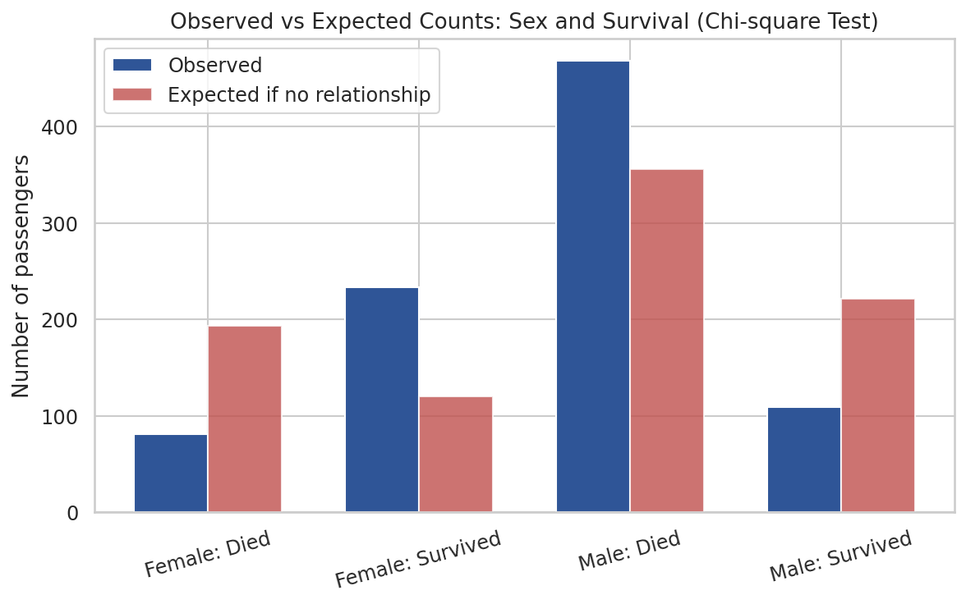
Figure 1: Observed counts vs the counts expected if sex and survival were unrelated
Result. χ²(1, N = 891) = 260.72, p < 0.001 (p = 1.2 × 10⁻⁵⁸). The effect size (φ = 0.54) is large.
Interpretation. p is far below 0.05, so H0 is rejected. There is very strong evidence that survival depended on sex. Figure 1 shows why: far more men died than expected under independence, and far more women survived than expected.

3.2 H2: Survival and Class
Hypothesis: H0: survival is independent of ticket class. H1: survival depends on class.
 | Did not survive | Survived | Total
1st class | 80 | 136 | 216
2nd class | 97 | 87 | 184
3rd class | 372 | 119 | 491

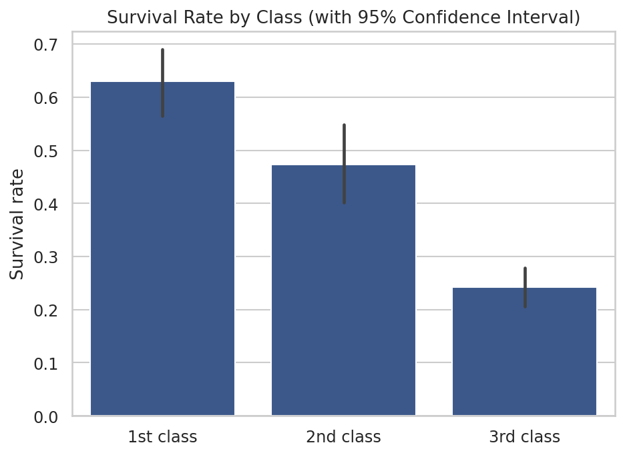
Figure 2: Survival rate by class, with 95% confidence intervals (non-overlapping intervals support a real difference)
Result. χ²(2, N = 891) = 102.89, p < 0.001 (p = 4.5 × 10⁻²³). The effect size (Cramér’s V = 0.34) is moderate to large.
Interpretation. H0 is rejected. Class and survival are related: 1st class had the highest survival rate (63.0%), 2nd class was close to even (47.3%), and 3rd class was lowest (24.2%). The confidence intervals in Figure 2 do not overlap between 1st and 3rd class, supporting a real difference rather than sampling noise.

3.3 H3: Fare and Survival
Hypothesis: H0: mean fare is equal for survivors and non-survivors. H1: mean fare differs between the two groups.
Statistic | Did not survive | Survived
Mean fare | 22.12 | 48.40
Median fare | 10.50 | 26.00
n | 549 | 342

fare_surv = df[df.Survived == 1]['Fare']
fare_died = df[df.Survived == 0]['Fare']

# Levene's test checks whether the two groups have equal variance,
# which decides whether a standard or a Welch t-test is appropriate
lev_stat, lev_p = stats.levene(fare_surv, fare_died)

# Variances differ significantly (Levene p < 0.001), so Welch's t-test
# (equal_var=False) is used instead of the standard t-test
t_stat, p_value = stats.ttest_ind(fare_surv, fare_died, equal_var=False)
print("t =", t_stat, "p =", p_value)

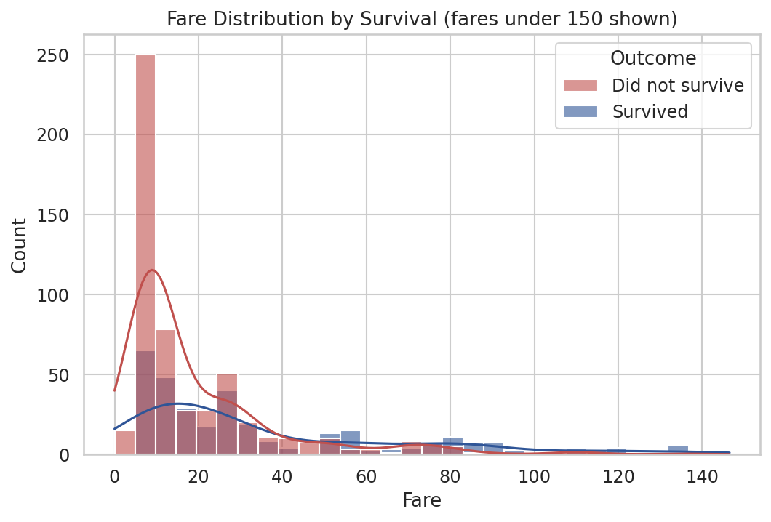
Figure 3: Fare distribution by survival outcome (fares above 150 excluded from the chart for readability)
Result. Levene’s test showed the two groups’ variances are significantly different (p < 0.001), so Welch’s t-test was used. t = 6.84, p < 0.001 (p = 2.7 × 10⁻¹¹). Cohen’s d = 0.50, a medium effect.
Interpretation. H0 is rejected. Survivors paid significantly higher fares on average (mean 48.40) than non-survivors (mean 22.12). Both means are pulled upward by a small number of very expensive tickets, which is why the medians (26.00 vs 10.50) tell the same story more conservatively. This mirrors the class result, since fare and class are closely linked.

3.4 H4: Age and Survival
Hypothesis: H0: mean age is equal for survivors and non-survivors. H1: mean age differs between the two groups.
Statistic | Did not survive | Survived
Mean age | 30.03 | 28.29
n | 549 | 342

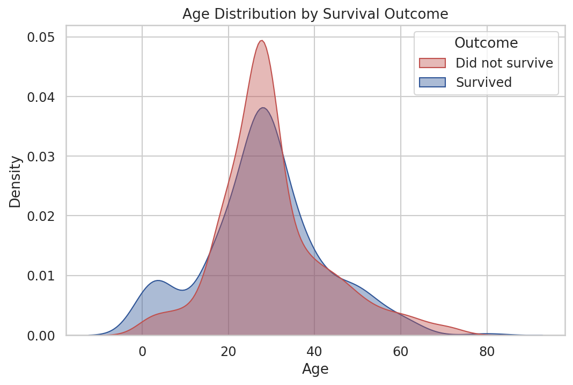
Figure 4: Age distribution by survival outcome
Result. t = −1.90, p = 0.058. Cohen’s d = −13, a small effect.
Interpretation. p = 0.058 is just above the 0.05 cutoff, so, strictly, H0 is not rejected: there is not quite enough evidence, at the conventional threshold, to say mean age differs between survivors and non-survivors. This is a useful result precisely because it is a near-miss: Figure 4 shows survivors have a second, smaller bump around early childhood that non-survivors lack, suggesting the effect may be concentrated in young children rather than spread across all ages. A t-test compares overall means and can miss an effect that only shows up in one age group, which is a limitation to note rather than a reason to force a conclusion. A p-value this close to the threshold should be treated as inconclusive, not as proof of no effect.

3.5 Additional check: Fare across all three classes (ANOVA)
As a supplementary test, a one-way ANOVA compared fare across all three classes simultaneously, rather than pairing survival groups.
Result. F(2, 888) = 242.34, p < 0.001.
Interpretation. Average fare differs significantly across the three classes, confirming what Week 1’s correlation analysis (Pclass vs Fare = −0.55) suggested. This is expected and mainly serves as a consistency check on the data.

4. Summary Table
Hypothesis | Test | p-value | Significant? | Effect size
H1: Sex vs Survival | Chi-square | < 0.001 | Yes | φ = 0.54 (large)
H2: Class vs Survival | Chi-square | < 0.001 | Yes | V = 0.34 (moderate)
H3: Fare vs Survival | Welch's t-test | < 0.001 | Yes | d = 0.50 (medium)
H4: Age vs Survival | Welch's t-test | 0.058 | No (borderline) | d = −13 (small)

5. Discussion
Three of the four hypotheses were supported at the 0.05 level, all with p-values far below the threshold, meaning the sex, class, and fare effects seen in Weeks 1 and 2 are very unlikely to be due to chance alone. The age hypothesis did not clear the threshold, which is itself informative: it suggests age’s effect on survival, if real, is not a simple shift in the average but is concentrated in a subgroup (very young children), consistent with the "children first" pattern noted in Week 2.
It is worth noting that these four variables are not independent of each other: fare and class are strongly linked, and sex ratios differ across classes. A test on one variable at a time, as done here, cannot separate these overlapping effects; a multivariate model would be needed for that, which is closer to the work planned for Week 4.
Statistical significance also does not by itself measure practical importance. The large sample size (891) makes it easier to detect small effects, which is one reason the effect sizes (φ, Cramér’s V, Cohen’s d) are reported alongside the p-values: they show that the sex and class effects are not just statistically detectable but genuinely large, while the fare effect is more moderate.

6. Conclusion
This week moved from visual impressions to formal statistical tests. Chi-square tests confirmed that both sex (p < 0.001, large effect) and ticket class (p < 0.001, moderate effect) were significantly related to survival on the Titanic. A Welch’s t-test confirmed that survivors paid significantly higher fares (p < 0.001, medium effect). The age comparison was inconclusive at the 0.05 level (p = 0.058), pointing to a more nuanced, subgroup-specific effect rather than no effect at all. These findings validate the strongest patterns observed in Weeks 1 and 2 with formal evidence, and set up Week 4, where several of these variables will be combined into a single predictive model.

Appendix: Complete Python Script
The script below reproduces every statistic and figure in this report. It requires Titanic-Dataset.csv in the same folder, and the pandas, numpy, scipy, seaborn, and matplotlib libraries.
import os
os.chdir(os.path.dirname(os.path.abspath(__file__)))

import pandas as pd
import numpy as np
from scipy import stats
import seaborn as sns
import matplotlib
import matplotlib.pyplot as plt

sns.set_theme(style='whitegrid', font_scale=1.05)

# ---------- 1. LOAD + CLEAN (same as Week 1) ----------
df = pd.read_csv('Titanic-Dataset.csv')
df['Age'] = df['Age'].fillna(df['Age'].median())
df['Embarked'] = df['Embarked'].fillna(df['Embarked'].mode()[0])
df = df.drop(columns=['Cabin']).drop_duplicates()
df['Class'] = df['Pclass'].map({1: '1st class', 2: '2nd class', 3: '3rd class'})
df['Sex'] = df['Sex'].str.capitalize()

alpha = 0.05

# ---------- HYPOTHESIS 1: Sex and survival (Chi-square) ----------
ct_sex = pd.crosstab(df['Sex'], df['Survived'])
chi2_sex, p_sex, dof_sex, exp_sex = stats.chi2_contingency(ct_sex)
n = ct_sex.sum().sum()
phi_sex = np.sqrt(chi2_sex / n) # effect size for 2x2
print("H1 sex vs survival")
print(ct_sex)
print("chi2", chi2_sex, "p", p_sex, "dof", dof_sex, "phi", phi_sex)
print("expected\n", exp_sex)

# ---------- HYPOTHESIS 2: Class and survival (Chi-square) ----------
ct_class = pd.crosstab(df['Class'], df['Survived'])
chi2_cls, p_cls, dof_cls, exp_cls = stats.chi2_contingency(ct_class)
k = min(ct_class.shape)
cramers_v = np.sqrt((chi2_cls / n) / (k - 1))
print("\nH2 class vs survival")
print(ct_class)
print("chi2", chi2_cls, "p", p_cls, "dof", dof_cls, "cramers_v", cramers_v)
print("expected\n", exp_cls)

# ---------- HYPOTHESIS 3: Fare and survival (Welch t-test) ----------
fare_surv = df[df.Survived == 1]['Fare']
fare_died = df[df.Survived == 0]['Fare']
t_fare, p_fare = stats.ttest_ind(fare_surv, fare_died, equal_var=False)
# Levene test for equal variance (to justify Welch)
lev_stat, lev_p = stats.levene(fare_surv, fare_died)
# effect size (Cohen's d, pooled sd) for reporting
pooled_sd = np.sqrt(((fare_surv.std()**2)+(fare_died.std()**2))/2)
cohend_fare = (fare_surv.mean()-fare_died.mean())/pooled_sd
print("\nH3 fare by survival")
print("mean surv", fare_surv.mean(), "mean died", fare_died.mean())
print("median surv", fare_surv.median(), "median died", fare_died.median())
print("t", t_fare, "p", p_fare, "levene_p", lev_p, "cohend", cohend_fare)

# ---------- HYPOTHESIS 4: Age and survival (Welch t-test) ----------
age_surv = df[df.Survived == 1]['Age']
age_died = df[df.Survived == 0]['Age']
t_age, p_age = stats.ttest_ind(age_surv, age_died, equal_var=False)
lev_age_stat, lev_age_p = stats.levene(age_surv, age_died)
pooled_sd_age = np.sqrt(((age_surv.std()**2)+(age_died.std()**2))/2)
cohend_age = (age_surv.mean()-age_died.mean())/pooled_sd_age
print("\nH4 age by survival")
print("mean surv", age_surv.mean(), "mean died", age_died.mean())
print("t", t_age, "p", p_age, "levene_p", lev_age_p, "cohend", cohend_age)

# ---------- ANOVA: Fare across 3 classes ----------
f_class, p_anova = stats.f_oneway(
df[df.Pclass==1]['Fare'], df[df.Pclass==2]['Fare'], df[df.Pclass==3]['Fare'])
print("\nANOVA fare across class: F", f_class, "p", p_anova)

# ---------- VISUALIZATIONS ----------
# Viz 1: observed vs expected counts for sex x survival
obs = ct_sex.values
exp = exp_sex
labels = ['Female: Died', 'Female: Survived', 'Male: Died', 'Male: Survived']
plt.figure(figsize=(9,5))
x = np.arange(4); width=0.35
plt.bar(x-width/2, obs.flatten(), width, label='Observed', color='#2F5597')
plt.bar(x+width/2, exp.flatten(), width, label='Expected if no relationship', color='#C0504D', alpha=0.8)
plt.xticks(x, labels, rotation=15)
plt.ylabel('Number of passengers')
plt.title('Observed vs Expected Counts: Sex and Survival (Chi-square Test)')
plt.legend()
plt.savefig('w3_viz1_chisq_sex.png', dpi=150, bbox_inches='tight'); plt.close()

# Viz 2: survival rate by class with CI
plt.figure(figsize=(7,5))
sns.barplot(x='Class', y='Survived', data=df, order=['1st class','2nd class','3rd class'],
color='#2F5597', errorbar=('ci', 95))
plt.title('Survival Rate by Class (with 95% Confidence Interval)')
plt.ylabel('Survival rate'); plt.xlabel('')
plt.savefig('w3_viz2_class_survival_ci.png', dpi=150, bbox_inches='tight'); plt.close()

# Viz 3: fare distribution by survival (histogram, log-ish via clipping)
plt.figure(figsize=(8,5))
d3 = df[df.Fare<150].copy(); d3['Outcome']=d3['Survived'].map({0:'Did not survive',1:'Survived'})
sns.histplot(data=d3, x='Fare', hue='Outcome', bins=30, kde=True,
palette={'Did not survive':'#C0504D','Survived':'#2F5597'}, alpha=0.6)
plt.title('Fare Distribution by Survival (fares under 150 shown)')
plt.savefig('w3_viz3_fare_hist.png', dpi=150, bbox_inches='tight'); plt.close()

# Viz 4: age distribution by survival
plt.figure(figsize=(8,5))
d4 = df.copy(); d4['Outcome']=d4['Survived'].map({0:'Did not survive',1:'Survived'})
sns.kdeplot(data=d4, x='Age', hue='Outcome', fill=True, common_norm=False,
palette={'Did not survive':'#C0504D','Survived':'#2F5597'}, alpha=0.4)
plt.title('Age Distribution by Survival Outcome')
plt.savefig('w3_viz4_age_kde.png', dpi=150, bbox_inches='tight'); plt.close()

print("\nDone.")

